Core Gear:
Gear Checklist Template:
*Remove/add Items as needed
- Backpacks (2)
- Sleeping Quilt
- Tent & Footprint
- Air Mattress
- Sleeping Pillows (2)
- Shoes/Boots/Gaters (2)
- Hiking Poles (2 sets)
- Headlamps (2)

Below Freezing Temp Additions:
- Closed Cell Foam Sleeping Pads (2)
- Second Down Quilt

Hydration:
- Hydration Bladders (2)
- Water Filtration Kit
- Water Bottles (2)

Rain, Bug, and Sun Protection
- Rain Cover/Garbage Bags (2)
- Buff/Bandana (2)
- Hats (2)
- Sunscreen
- Bug Repellant
- Mosquito Nets (2)
- Lip Balm (2)
- Sunglasses (2)

GPS, Phones, Power:
- Phones (2)
- Power Bank
- Charging Cord
- Batteries for Tent
- GPS Messenger
- Download GPS Map

Cold, Snow, Ice Travel:
- Microspikes (2)
- Ice Axes (2)
- Seal Skinz

Personal Hygiene:
- Travel Toothbrushes (2)
- Travel Toothpaste
- Travel Deo
- Body Wipes
- Face Sunscreen
- Hair Bands
- Salve

Bathroom Accessories:
- TP
- Trowel
- Flushable Biodegradable Wipes
- Feminine Hygiene Products

Food Prep, Storage, and Garbage:
- Bear canister/Ursack
- Stove
- Fuel
- Lighter
- Spoons (2)
- Pot
- Camp Towel
- Sanitizer Spray
- Our Trash Bag (Large Ziplock)

Food, Snacks, and Supplements:
- Food Pouches
- Bars
- Banana Chips/Dried Fruit
- Energy Drink Stix
- Salty Snacks
- Trail Mix
- Supplements

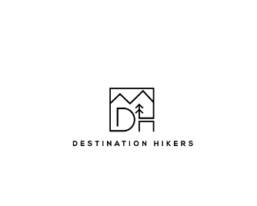
Other:
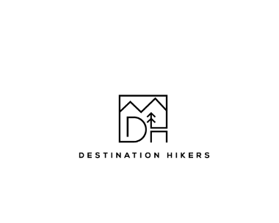
- Nylon Rope
- Small Multitool
- Ear Plugs

Emergency, First Aid Kit:
- Backup Water Purification Tabs
- Band-Aids
- Liquid Bandage Spray
- Medical Tape
- Antibiotic Ointment (Bacitracin or other)
- Alcohol Prep Pads
- Moleskin
- Sprain Wrap
- Aleve, Tums, Charcoal, Benadryl, Zyrtec-D
- Backup Glasses/Contacts
- Extra pair of dry socks

Clothing:
- Camp Shoes (2)
- Dry Bag
- Socks
- Compression socks
- Beanie
- Gloves
- Handwarmers
- Shorts
- Pants
- Tights
- Undershirts
- Mid-layers
- Fleeces
- Down Jackets
- Rain Jackets

